

August 12, 2005

Dear Honorable Mayor and Members of Vandalia City Council

Attachments:
- Council Package
- Airport Executive Summary with biographies

Miscellaneous:
- Two reminders: The ATA opening ceremony is Monday, August 15 beginning at 7:00 p.m. at the Grand Stand. The Council meeting will be Thursday, August 18 with a workshop at 7:00 p.m. and the meeting at 7:30 p.m.
- The Cassel Woods PUD/rezoning case will be taken off the agenda and will go back to the Planning Commission. The applicant did NOT have a complete PUD submittal and we do not want to get into another American Legion situation. I have contacted Greg Barney and he is aware of this. We will also contact the neighbors and let them know the item will NOT be at the meeting on August 18. This project will eventually come back to City Council, but probably not for a month or so.
- I spoke with Christy Donnelly and Joe Flanagan regarding a joint meeting in August since there are five Mondays. The Schools will host the event at 7:00 p.m. on August 29 at their administrative offices.
- I have attached the “Executive Summary” regarding Williams Aviation with biographies from the two principals. This will be in front of you at Thursday night’s meeting. I have enclosed a separate memo for the Action Item in the Council packet. I hope this is the information you were looking for.
- The Schools are having banners made congratulating the students and schools for their “excellent” rating. They will give us banners to put up at the Government Center and VRC. These will probably go up on August 20.
- We will be closing the aquatics center for the annual maintenance. We had to close it down a few days early because our pump went out. If you recall, we actually bought a back up because we knew the pump was on its last breath. This foresight by the Parks Department saved us between 6-8 weeks of “down-time” because it would have taken that long for a new pump to have been ordered and installed. The aquatics center will be down for a week or so.
- We recently had a dispatcher resign to take a job with Montgomery County. We are now down two dispatchers (both from this year) and will fill one of the positions. This will keep us staffed enough and help keep overtime low. This will make us one dispatcher short and one police officer short.
- Just to make sure everyone is aware, about a month ago, Dayton did exercise their option on the ATA land. We all knew this was going to happen and it did. I was able to get a copy of the Airport Layout Plan. They dropped it off this week.
- F&S continues to move forward with their expansion plans. The owner met with staff this week and showed the new preliminary design of the building. We are working with them to install some public utilities that will be paid for by the TIF. They hope to have more information to us over the next few weeks.
- The Little York Tavern officially bought the former Damons building. They will be doing a lot of interior work and hope to open in October or November.

Sincerely,
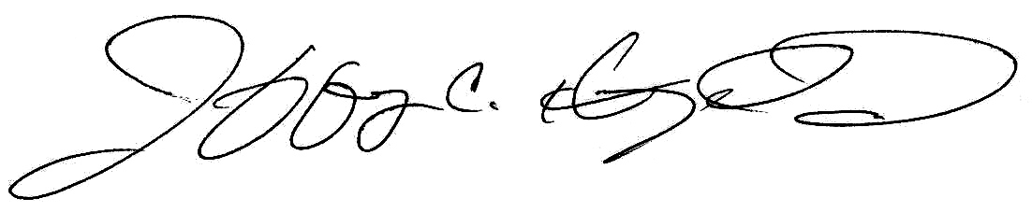
Jeffrey C. Hoagland
City Manager

